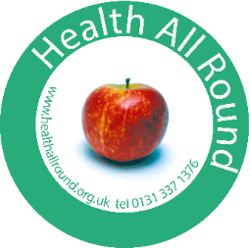

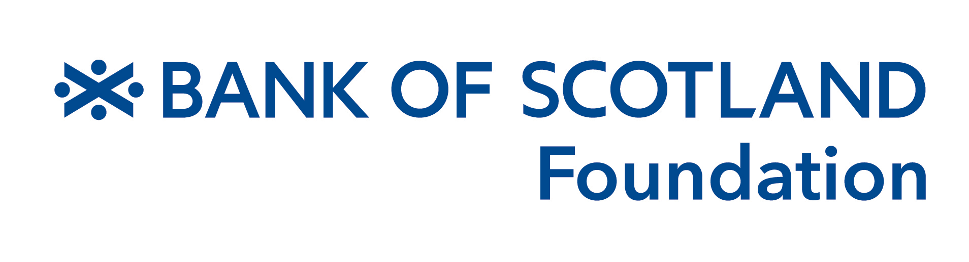

Health All Round Well Being Group Worker – Additional Info:

Health All Round (HAR) is a community health project supporting local people to live longer, healthier lives. We have been in operation since 1989, supporting 250 – 260 people every week with a broad range of services designed to improve mental, physical and social well being. We are a small organisation that packs a hefty punch because we enlist the support of 40+ volunteers and we bring local people together to support one another. We have close working links with local GP practices and other health professionals.

People can self refer to HAR but most are referred via their GP and have a long term physical and / or mental health condition. We are located within areas which score high on the Scottish Index of Multiple Deprivation (SIMD). Some of the GP practices we work with are based within the most deprived 5%, others are within the most deprived 10% and 20%. There is strong evidence that people living within these areas face poorer health outcomes: higher rates of depression and anxiety; poorer life expectancy; poorer diets; lower physical activity; increased contact with psychiatric services.

HAR services include: Well Being Service (building emotional resilience); Action for Pain (using a mind/body approach to manage chronic pain and fatigue); Go for Green and Active Steps (healthy eating, increased physical activity in greenspace); Vibrant Years Club (social groups and befriending for older adults); Art for Health (arts and creativity for health); Community Link Workers (supporting GP patients to access third sector services).

HAR registers about 500 new people each year. 80% of those accessing our services are either retired, unemployed or not working due to ill health, with a further 37% identifying as disabled. Our services are robustly evaluated and we have plenty of evidence to demonstrate impact on: improved mental / emotional health; reduced loneliness; increased confidence to manage own health & wellbeing; increased connections within the local community; increased physical activity & healthy eating.

The Wellbeing service includes both one to one support and psycho-educational groups, focusing largely on anxiety and low mood/ depression. As with all HAR services we aim to help participants develop their understanding of these common but troublesome experiences, to be less fearful of what is happening to them, develop self compassion, reduce avoidance behaviour and work towards their own chosen goals. This service includes three part time staff: Well Being Development Worker (lead role for counselling/psychotherapy); Well Being Group Worker (lead role for psycho-educational groups); Ecotherapist. The material and resources for the psycho-educational groups have been developed over the years by a qualified CBT therapist and, while we are always open to new suggestions, this aspect of the service is in place and ready to go.